POSITION PAPER
August 2025
Hospitality in the circular economy
Policy recommendations and action paper
- INTRODUCTION
- OUR VISION OF A CIRCULAR HOSPITALITY SECTOR
  - Opportunities from ‘going circular’
  - Challenges to ‘going circular’
  - Hospitality contributions to the circular economy: Case studies
- POLICY RECOMMANDATIONS
- HOTREC ACTION PLAN

- INTRODUCTION
In the context of the public consultation on the Circular Economy Act to be adopted by the end of 2026, HOTREC presents its vision for a circular hospitality sector for sustainable growth and environmental stewardship. This vision highlights tangible contributions of hotels, restaurants, bars, and cafés to the circular economy — a system designed to maintain the value of products, materials, and resources for as long as possible.
In a circular economy, products and materials are kept in circulation through processes like maintenance, reuse, refurbishment, remanufacture, recycling, and composting in accordance with the EU waste hierarchy (below).
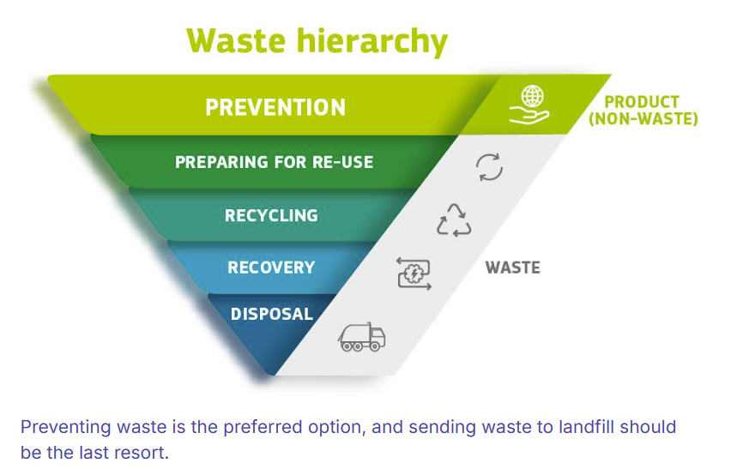
This paper outlines policy recommendations across three core pillars of circularity in hospitality: waste management, food waste reduction, and reuse, while prioritising small businesses. We emphasise the need to invest in training to foster a well-functioning and competitive circular hospitality sector. Additionally, we propose HOTREC targeted actions, aligned with the waste hierarchy and reflecting prevention, reuse, and recycling measures.

- OUR VISION OF A CIRCULAR HOSPITALITY SECTOR
With over 2 million businesses employing 10 million individuals, the European hospitality sector is a major economic contributor (3% of the total EU GDP), driven overwhelmingly by small and medium-sized enterprises, which account for 99% of all operators. The hospitality industry is highly dependent on nature and resource intensive. In 2019, hospitality accounted for 20% of the tourism industry total carbon emissions. At the same time, tourism revenue and the presence of visitors, fuel conservation efforts, protected areas, and local economies.
- Opportunities from ‘going circular’
The circular economy offers substantial opportunities for hospitality to boost economic performance while promoting sustainability. From reducing costs through streamlined operations to minimising waste, circular solutions can lead to economic and reputational gains, and make local communities flourish. Attracting environmentally conscious customers can further expand the customer base. Adopting circular practices can boost staff recruitment and retention, especially among millennials.
- Challenges to ‘going circular’
However, challenges such as initial investment costs and lack of immediate return on investment can impact businesses, especially Micro, Small and Medium Enterprises (MSMEs). Regulatory uncertainty and complex administrative processes add to the burden, while a shortage of skilled professionals and the need for extensive training on circularity further complicate the picture. Hospitality operators are increasingly dependent on suppliers for various circular solutions, including sustainable packaging, water reduction systems, and circular textiles. However, the lack of standardised approaches to circularity across different industries and regions can lead to fragmentation.
Studies also show that travellers can adopt different consumer behaviours than at home, for instance using almost double the water compared to when they stay at home. The gap between what sustainable activities travellers say they want and what they do while travelling is well documented and can constitute a challenge for hospitality operators applying circular solutions.
Addressing these issues requires coordinated efforts from businesses, governments, and stakeholders to create a supportive environment through financial incentives and regulatory stability.
- Hospitality contributions to the circular economy: Case studies
Despite these hurdles, we would like to highlight practical contributions of hospitality operators to the circular economy:
- Example of efficient waste prevention and reduction
- Example of extending the life span of furniture
- Example of consumer awareness raising

- POLICY RECOMMANDATIONS
The current circularity rate in the EU stands at 12%. HOTREC commits to sustainable growth and environmental stewardship by presenting policy recommendations to EU policy makers to foster circularity in the hospitality sector:
Policy recommendation 1: Support tailored made waste collection for hospitality:
- Consider the complexity of managing different waste streams, such as refillable or single use, organic or non-organic waste and high costs of separate waste collection subject to seasonal fluctuations and consumer behavior.
- Promote frequent door-to-door separate collection of waste in hospitality
  - Due to limited space to store all types of waste in restaurants and cafés - even more in urban areas - and variations in waste volumes, it’s essential to support frequent collection of waste in our establishments.
  - Door-to-door collection systems show positive results across Europe to achieve the highest recycling rates and high-quality recyclables. However, Deposit Return Schemes (DRS) or conventional public waste containers constitute barriers for the hospitality sector.
- Do not include hospitality in the scope of Extended Producer Responsibility (EPR)
  - Hospitality operators should not be considered as ‘producers’ unlike manufacturers responsible for the end of life of products that they place on the market. Hospitality risks being double charged by private waste collection fees on top of EPR fees.
  - Avoid fragmentation and inconsistencies of EPR schemes and ‘polluter pay’ principles in the EU.
  - Encourage private run-EPR ensuring effective investment in separate waste collection and recycling. The opposite scenario could hinder recycling efficiency, limit packaging choices, and increase packaging costs for the hospitality sector due to the mandatory recyclability of all packaging by 2030 as stipulated in the PPWR.
- Support harmonised and comprehensible waste sorting instructions for packaging Harmonised and clear information to consumers on how to sort packaging waste and facilitate waste management by hospitality staff and consumers. It will contribute to improve packaging recyclability rates across the EU.
Policy recommendation 2: Promote food waste reduction measures tailored to hospitality
- Allow separating edible and non-edible food waste in measurements. In Sweden, in 2024, only 25% of the food wasted in hotels and restaurants was edible (unlike 100% in retail). We call on the Commission to separate edible from non-edible food waste in measurements during the review of the waste framework directive foreseen in 2027. This level of granularity will help capture a more accurate picture of the sectorial situation and then adopt the most appropriate measures.
- Consider tailored solutions to facilitate the donation of unsold food that is safe for human consumption in hospitality. From 2026, Member States will indeed be required to take measures ensuring that economic operators with a significant role in the prevention and generation of food waste facilitate food donation as mandated by the revised waste framework directive. Solutions could be EU-wide VAT exemptions for donated products, lowering high distribution costs and financial incentives. Formal and mandatory food waste measurement and reporting is less suited to small businesses and would not be cost effective.
- Renew the mandate for 2027-2031 of the EU Platform on Food Losses & Food Waste. HOTREC believes we should continue to share best practices and initiatives showcasing hospitality establishments successfully tackling food waste at local level.
Policy recommendation 3: Enhance reuse
- Clarify the legal framework for reuse in the EU by speeding up guidance on reuse obligations arising from the Packaging and Packaging Waste Regulation (PPWR) including on preferred materials, recyclability of reusable packaging and the acceptable number of rotations for packaging.
- Promote reuse when offering environmental benefits through specific initiatives while maintaining customer convenience.
- Showcase best practices in expanding the life span of hospitality furniture and textiles and other efforts aimed at prolonging the life of equipment.
- Tackle the issue of double VAT and double payment processing fees on deposit for reusable packaging in hospitality.
HOTREC is committed to working with EU policy makers and stakeholders to promote a sustainable and circular economy within the hospitality sector.
Policy recommendation 4: Ensure regulatory certainty and invest in training essential for businesses to effectively plan and implement circular economy practices.
- Provide economic tools and measures for Member States and economic operators to "go circular" rather than setting unachievable and burdensome new targets.
- Invest in education and training on circular economy
Studies show that training hospitality staff, at all levels, on circular economy and design can have a powerful multiplying effect within the organisations.

- ACTION PLAN
Acknowledging the resource-intensive nature of hospitality, we have set goals within three core pillars, coupled with concrete actions, for HOTREC to achieve within the next two years. Our four pillars should be complemented by three horizontal focus areas:
- Considering MSMES tailored needs to implement circular models
- Encouraging collaboration with local suppliers and local communities
- Raising consumer and staff awareness
See below

Objective | Goals | Actions | Timeline
1. Managing waste | Improving waste collection for recycling | Action 1: Advocate for door-to-door separate collection of packaging waste in HORECA | 2027
1. Managing waste | Improving waste collection for recycling | Action 2: Produce studies on successful waste collection in hospitality in Europe | 2026
1. Managing waste | Improving quality of glass collected for recycling in HORECA | Action 3: Launch communication project to reduce glass contamination by ceramic in restaurants with Close the Glass Loop | ongoing
2. Reducing food waste | Support member states in meeting food waste reduction targets by 2030 | Action 4: Play an active role in the EU platform FLFW and inform national authorities on recommended measures | ongoing
2. Reducing food waste | Support local food waste reduction  Initiatives | Action 5: Encourage awareness-raising with staff and clients | 2026
3. Enhancing reuse | Facilitate the uptake of reuse in food-led businesses | Action 6: Create guidelines for hospitality businesses on reuse and refill obligations arising from PPWR | ongoing
3. Enhancing reuse | Expand the lifespan of furniture and equipment in hotels and restaurants | Action 7: Contribute to sleep circular project on end of life of mattresses | ongoing
3. Enhancing reuse |  | Action 8: Establish partnership with the European Waste Management Association (FEAD) | 2027

Definition of a circular economy, Ellen MacArthur Foundation.
Insert link to commonly used EU waste hierarchy.
UN Tourism and the Sustainable Development Goals – Journey to 2030, January 2018.
WTTC x Harvard, Learning Insights, Leading Circularity in Travel & Tourism, May 2022.
Sustainability Trends in Hospitality: Strategies and Examples, March 2025.
A US survey revealed that 40% of millennials pick employers based on sustainability. Also, 70% are more likely to stay with environmentally responsible companies.
Assessment of water use and re-use in hospitality businesses, 2016.
How to Create the Sustainable Travel Products Customers Want, white paper December 2022.
Eurostat: the EU’s circular material use rate rose slightly in 2022 | European Circular Economy Stakeholder Platform
Study on one-way glass beverage packaging in the HORECA sector, December 2022.
Harmonisation of waste separate collection across Europe, Position paper, July 2020, EEB and Zero Waste Europe.
See this project of bio organic waste collection for hospitality in Spain, Malaga.
Letter-from-UKHospitality-to-SoS-Steve-Reed-18-March-2025.pdf
Circular economy act FEAD policy recommendations, May 2025.
Joint Industry Statement on State-run Producer Responsibility Organisations, May 2025.
Joint industry statement for harmonized waste sorting labels, July 2025.
Impact Assessment, Improved Food Waste Reporting, DEFRA, May 2022, p.43.
Circular Economy in the hospitality industry Materia Rinnovabile | Renewable Matter

